Sign/symbol | Transcribe | Comment | Betekenis
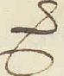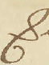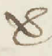 | ver | This signs always means: ver. Expand the abbreviation. | ver
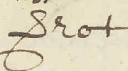 | verrot | Expand the abbreviation. | Verrot
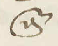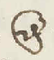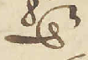 | ende | Expand the abbreviation. | Ende
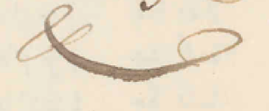 | & |  | &
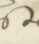 | st |  | St
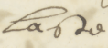 | laste |  | Laste
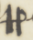 | pp |  | Pp
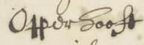 | Opperhooft |  | Opperhooft
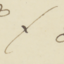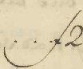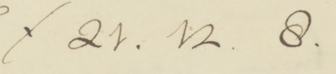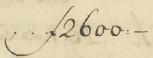 | ƒ (U+0192) | florin sign | Florijnteken
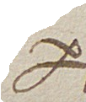 | per | Expand the abbreviation. | Per
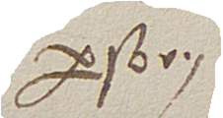 | persoon | Expand the abbreviation. | Person
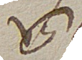 | van | Expand the abbreviation. | Van
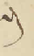 | en |  | En
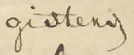 | gisteren | the downward line is an: n | Gisteren
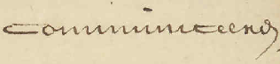 | communiceeren |  | Communiceeren
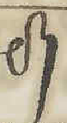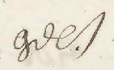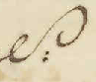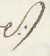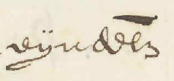 | l/lijk | Expand the abbreviation. | Lijk
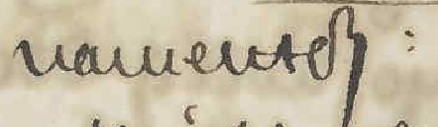 | namentlijk: |  | Namentlijk
 | gelijk |  | Gelijk
 | eijndelijk |  | Eijndelijk
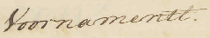 | Voornamentl. | Compare above. | Voornamenlijk
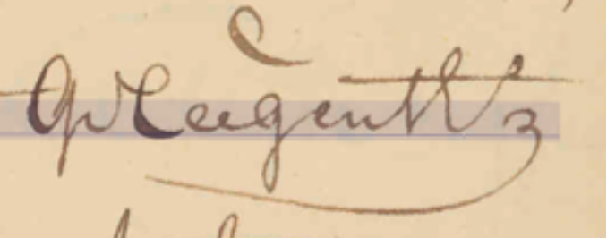 | gelegentheid | Expand the abbreviation. | Gelegentheid
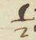 | ½ (U+00BD)
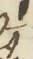 | ¼ (U+00BC)
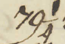 | 79¼
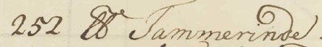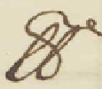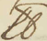 | lb | This is a pound (weight) symbol and must be transcribed as: lb | Pond (gewicht)
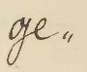 | ge„ (U+201E) | At the end of a line, words are sometimes split in half, followed by a double low-9 quotation mark, transcribe with the following Unicode: „ (U+201E) | Ge
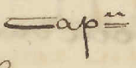 | cap=n |  | Kapitein
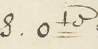 | S. O=te | Cardinal direction. Other directions are abbreviated similarly. | Zuidooste
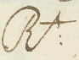 | R:t
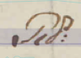 | Rd: | Rijksdaalders. | Rijksdaalders
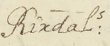 | Rixdal:s | Rijksdaalders. | Rijksdaalders
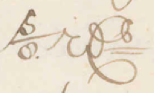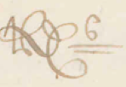 | rx=s | Rijksdaalders. | Rijksdaalders
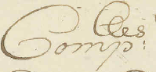 | Comp:es |  | Compagnies
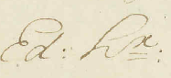 | Ed: H=r: |  | Edele Heer
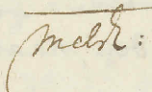 | Melch:
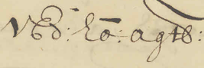 | VEd: Ho: agtb: |  | U Edele Hoog Agtbare
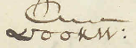 | voorn: |  | voornoemde
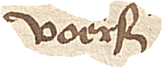 | voers |  | voorsegde
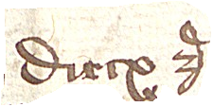 | Dircx z |  | Dircx zoon
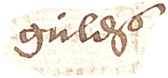 | gulds |  | guldens
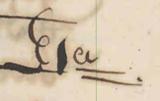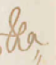 | Et=a | Etcetera | Etcetera
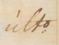 | ult:o | Last day of the month. | Ultimo
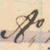 | A„o | Anno. | Anno
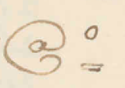 | @=o | Anno. | Anno
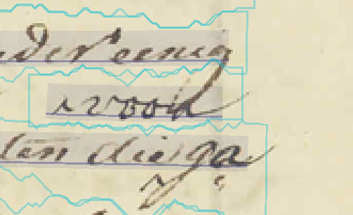 | ^voor | ^ is used to mark an insertion.
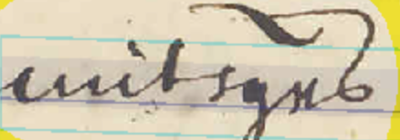 | mitsgrs |  | Mitsgaders
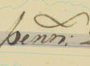 | penn: | Penningen | Penningen
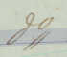 | d„o | Dito. | Dito
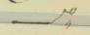 | _„o | Dito. | Dito
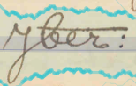 | Jber: | September. Sometimes written with as ‘7ber’. | September
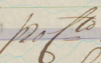 | pro C=to | Percent. | Procent
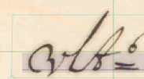 | vlt=o | Ultimo (last of the month). | Ultimo
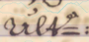 | ult=o | Ultimo (last of the month). | Ultimo
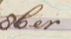 | 8ber | October. | Oktober
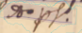 | Ao. ps.o | Anno passato (last year) | Anno passado
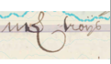 | m& troijs | Mark troys (gold) | Mark troijs

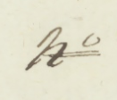 | n=o |  | Nummer
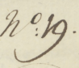 | n:o 19. |  | Nummer
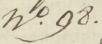 | n.o 98. |  | Nummer
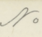 | No |  | Nummer
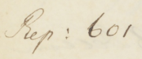 | Rep: 601
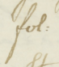 | fol: |  | Folio
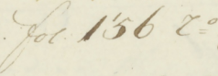 | fol. 156 r=o |  | Folio
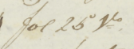 | fol 25 V=o |  | Folio
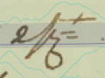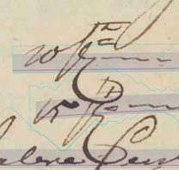 | /c=t | Percent sign | Procent
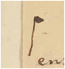 | ¶ (U+00B6) | Pilcrow sign, insertion mark
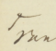 | ^van (U+005E) | Insertion sign
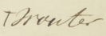 | ^Wouter
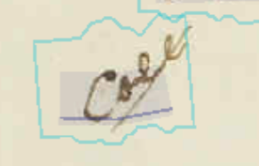 | Coll
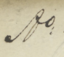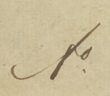 | A:o |  | Anno
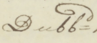 | Dubb=d
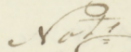 | Not=s |  | Notaris
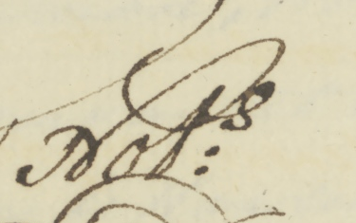 | Not:S |  | Notaris
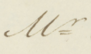 | M=r |  | Meester
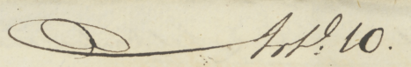 | Art:l 10. |  | Artikel
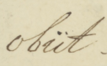 | obiit
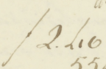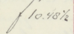 | ƒ (U+0192) | Florin sign

